.Net with Azure
Topics -
- App service
- Deployment is seamlessly integrated with VS studio
- Azure SQL
- Not have to worry about managing SQL server deploying or worrying about the backup.
- Azure makes life super simple with SQL database SQL servers backing them up, restoring them along with all the security service.
- Storage account
- typically applications will also have files that they have to manage and sometimes keeping everything in App service is not the best approach.
- Azure has a solution storage accounts in Azure is a Microsoft managed service that provides cloud storage and works seamlessly with the coding when you have to add file there, delete a file or do some operations using programming
- Azure functions
- many times we need a functionality that triggered when you hit some endpoint or a job that you need to do on a schedule
- Azure function is a perfect way to get it done in an efficient manner without creating a virtual machine or deploying an application
- azure is a server less solution that allows you to reduce the coding and reduce infrastructure while saving on the cost at the same time.
- Logc Apps
- they are kind of similar to func in ways that there are triggered that will invoke a logic app and an azure func but with logic app, you do not have to write a code, then can be built without writing a single line of code, they are more like drag and drop and you build a flow.
- but because of that It can be less flexible to azure func, bcs you can write code in azure function.
Ex - your organization has all customer details and if add new, you need to notify and create a record in sql database. You can do it with the logic app bcs all the connectors that are built in inside the logic app.
- They have connectors for many functionality.
- Azure cache for Redis
- fully managed memory cache, build of in ready software. It is capable of handling millions of requests per second, and best part- fully managed by Microsoft.
- App Configurations
- provides service to centrally manage the application settings of your applications and something called feature flags.
- feature flage
it is great when you want to release new software only to internal users first and then toggle a switch for all customers.
- using them we can manage the feature availability in real time.
- Azure devops
- azure git | ci/cd | ticket management

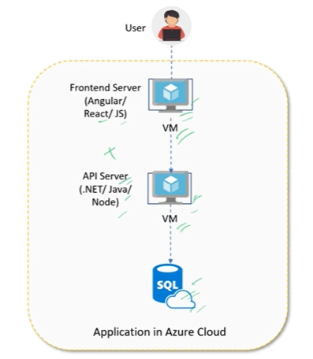
Instroduction to cloud and Azure
- What is cloud computing? What is Azure?

- Cloud computing is the delivery of computing services like
Servers, storage, databases, networking, software and AI
Over the internet (the cloud) instead of using physical
Hardware or local servers.
- Azure is a cloud computing platform providded by
Microsoft, offering a wide range of services for building
, deloying and managing applications and infrastructure.

- Advantages of sing Azure over on-premises server.
- cost savings - pay as you go - no need to buy any expensive hardware; pay only for what you use.
- Auto scaling and flexibility - Automatically increase or decreases resources based on the demand. Instant loads can be handled. Ex - on weekends, load Is hire.
- High availability - 99.99% uptime
- disaster recovery - automated disaster recovery and data backup because data is stored across multiple data center.
- Advanced security - Ai driven threat detection, encryption and multi layer security.

- What are the main cloud service models. Explain difference between Iaas, Paas, Saas with azure example.
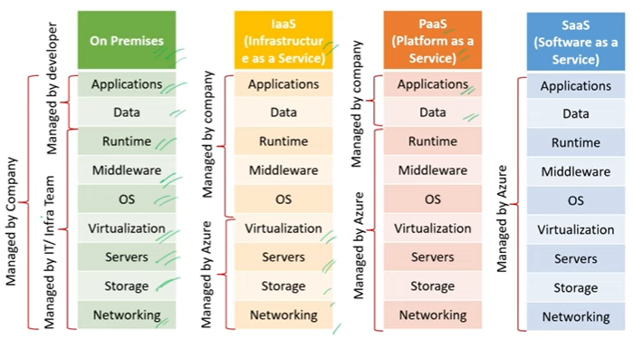
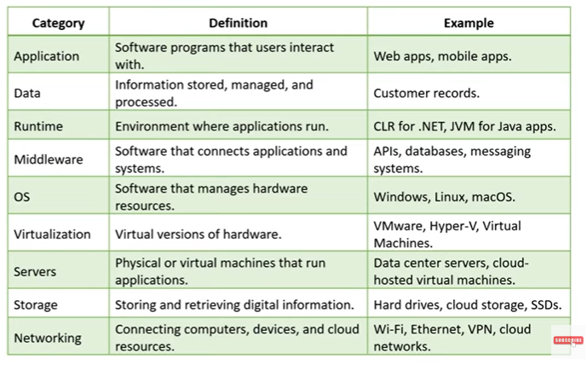

- What is azure portal? What are top 20 azure services?
Azure.portal.com - web based platform to create and use services.
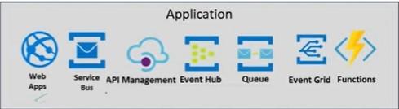
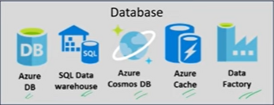
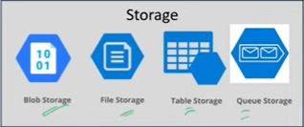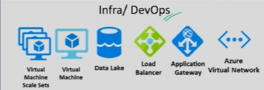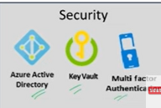

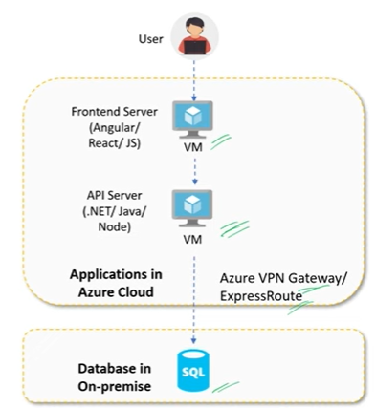
- What is hybrid cloud?
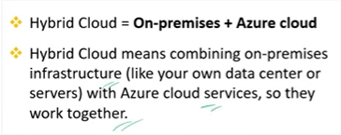

II) Azure Resource Manager
1. What is resource in azure? How it is different from a service in Azure ?
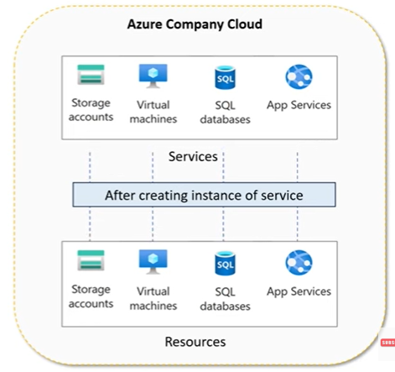
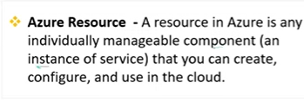
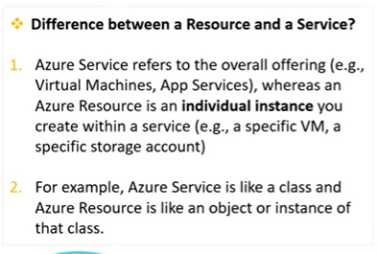

- What are Resource groups in Azure? Why do we use them in projects?
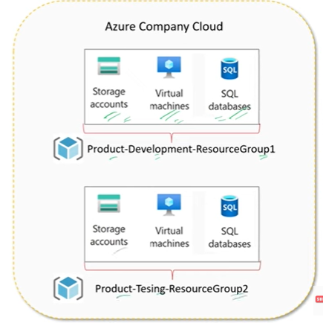
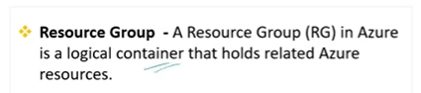
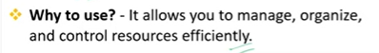

- How do you decide which resources to keep in the same resource
Groups?
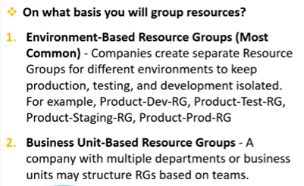

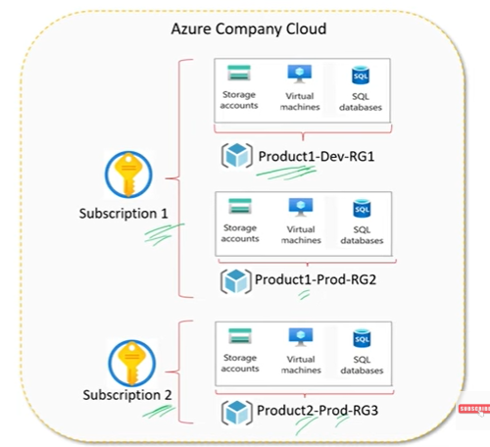
- What are Azure Subscriptions?
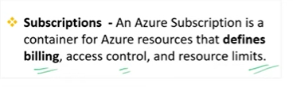
- How does access control differ between subscription
Level and resource group level

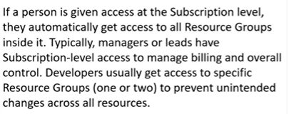

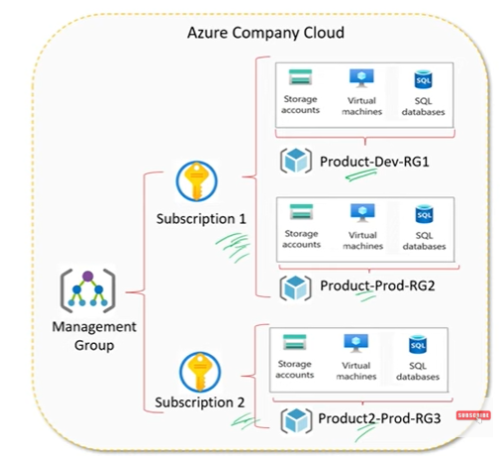
- What are management groups in Azure? Can you give an example

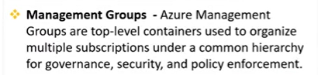
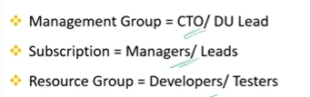

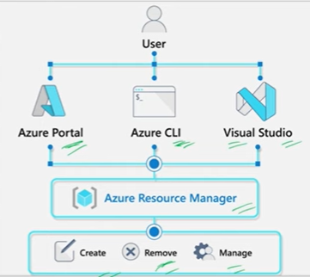
- What is Azure Resource manager and what is its role?

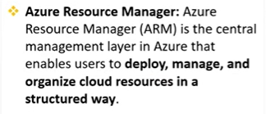
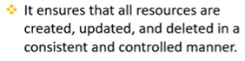

- Can you explain Azure Regions and Availability Zones? How are they different?
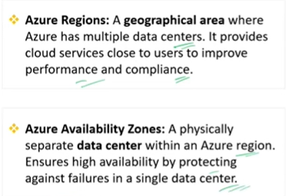

III) Azure Compute Services
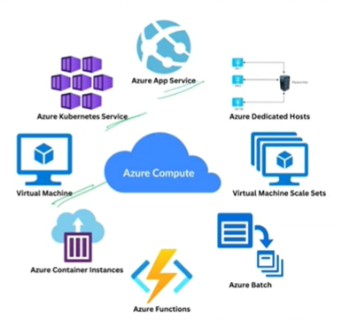
1. What are Azure Compute Services? Name a few.
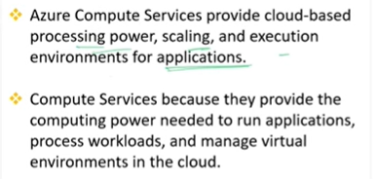

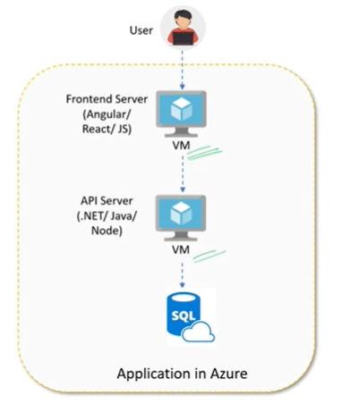
- What are Azure Virtual machines? When would you use them in a project?
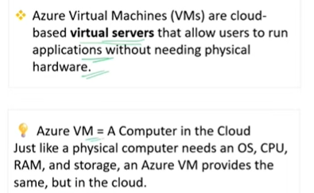
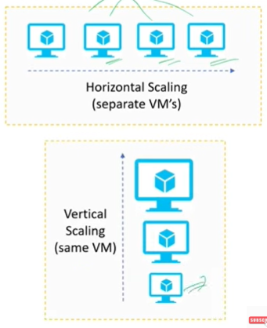
- What are difference between horizontal and vertical scaling? When to use what?
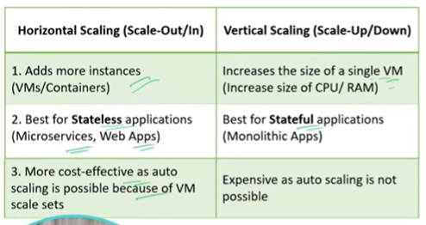

- What are VM scale sets? When will you use them in your project?
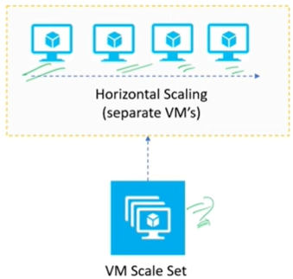
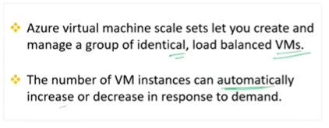

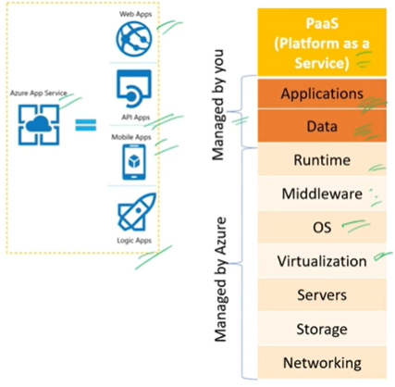
- What is Azure app services? For what purpose can you use them?
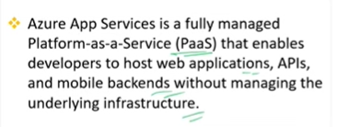

- Main feature or advantages of using Azure App Service
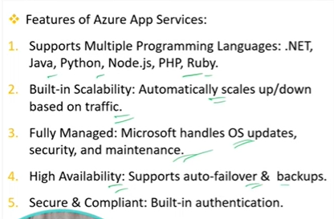

- Azure VMs vs Azure App service, when to use what
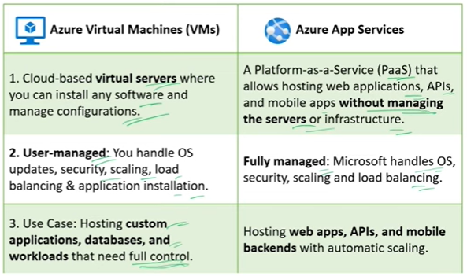

IV) Azure Functions
1. What are Azure Functions? Have you ever used them in your project? Why?
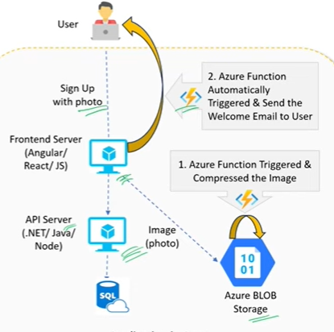

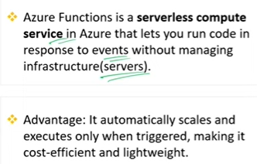
Written in c#, java, javascript

- Why not include the Azure function code directly
Within the main application or what is advantage of azure
function

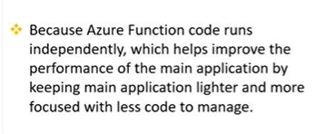
- What exactly is server less in azure? Is it truly server less?
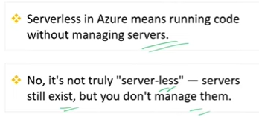
- What are triggers in azure functions? Can you name a few types.
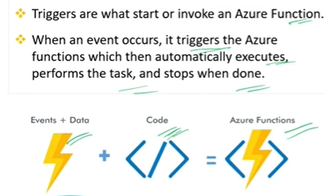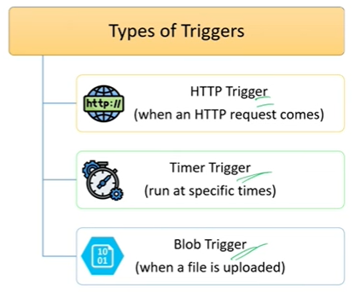

- What are the important steps to write code of an Azure function? Share example.
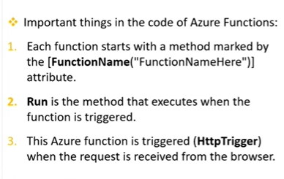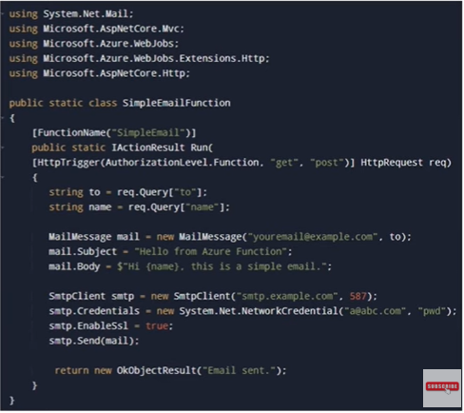

- What are Azure Logic Apps?
Workflow automation
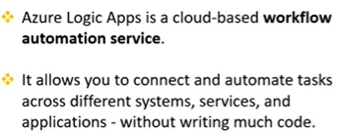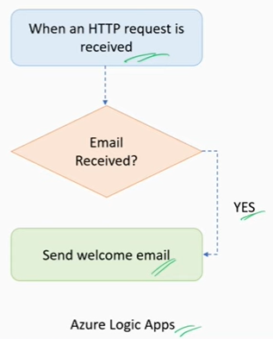

- How Azure logic apps are different from azure functions? When to use what?
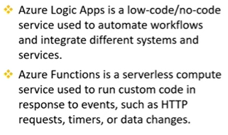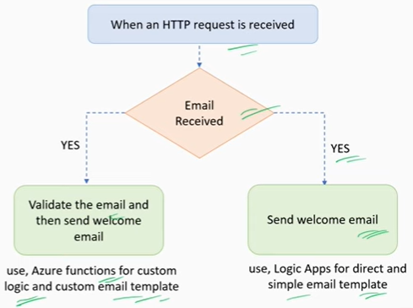

V) Azure storage service
1. What is Azure storage and it’s type.
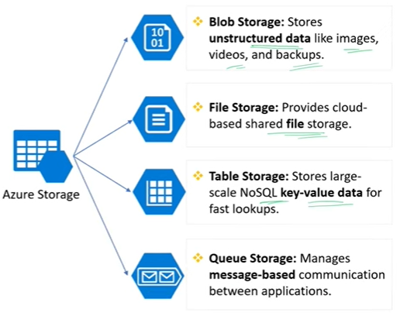
- Azure Blob storage
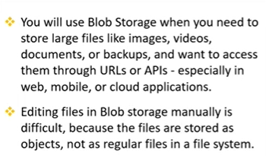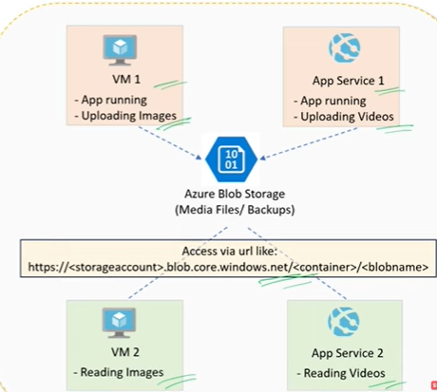

- File Storage
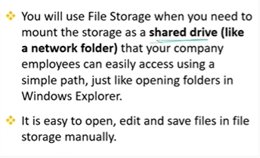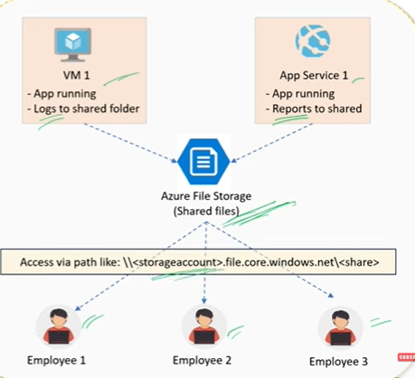

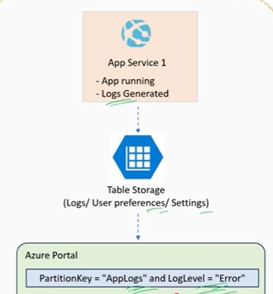
- Table storage
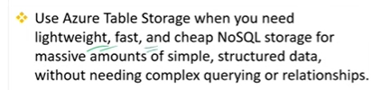
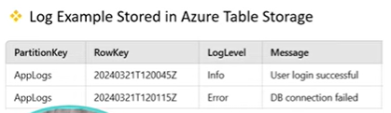

- Queue storage
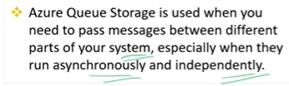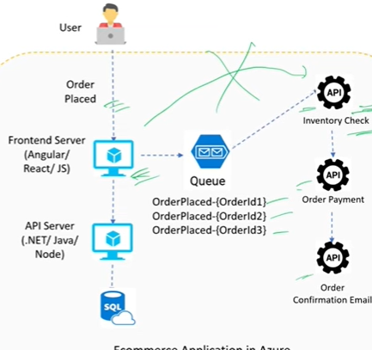

- What is Disk storage and how does it support VMs?
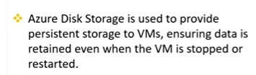

VI) Azure Database Services
1. What is Azure SQL database? How it is different from regular SQL server?
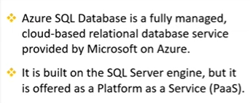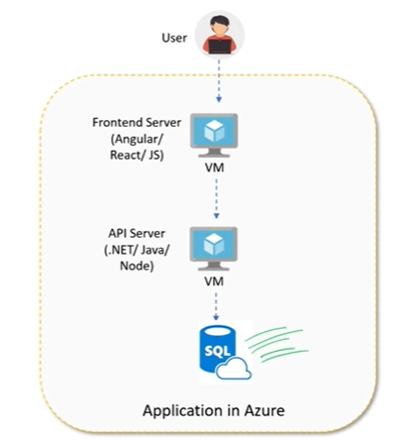

- Difference between Azure SQL managed instance and Azure SQL Database
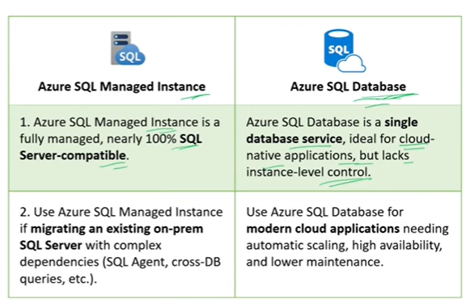

- Azure cosmos DB.
- NOSQL
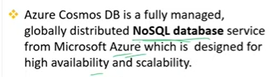

- When to use what
